Randomly Generated racetracks
Main Sources:
https://github.com/juangallostra/procedural-tracks
https://www.statox.fr/posts/2021/10/race_generator/
To generate procedurally generated tracks, there are several approaches. The first approach we were considering was joining different unique track segments together to make a unique track experience to every race, but there were several drawbacks to this implementation, some are listed here:
- Track segments could overlap, and result in a catastrophic failure to the racing experience.
- Track width and height on canvas can be variable, which will cause trouble displaying it on the mini-map.
- Track design will be mostly linear
So, looking at other solutions online to the same problem, a new solution was in place.
We will make the tracks by taking the following steps:
- Generate random points on the map, in a circular manner
- Generate splines and spline points between these random points to join them together in a smooth fashion.
- Provide track width by using inversed tangents to the spline curve, to extend from the original track design
- Turn this created track into a grid, where 1’s represent track, and 0’s represent grass. We turn this grid into an array using linear interpolation from the left to the right segments of the track, above the spline.
- Represent that grid on the renderer
This will also allow us to confidently spawn the player within track limits.

Generate random points on the map, in a circular manner
Circles are the base of all tracks, since we measure progress in laps, a circle-like track is a must have for the game. To create circular tracks, we part from a circle, and we play with the properties of the circle to make it more interesting.
We define the number of turns our track will have (N), and divide a circumference by N, meaning that every turn will occur at the exact radial distance. Now to make the track more expressive, and fun, we add a random factor to the radius of the circle that’s being generated at that point of the radial circumference.
Radius = base radius + random float (0-1) * number (scalar like numb)
We create each iteration of the circle from a center point in the map (32,32), then we generate the radius, and find the x, y of the point by using these formulas:
X = center_X + radius * cos(angle)
Y = center_Y + radius * sin(angle)
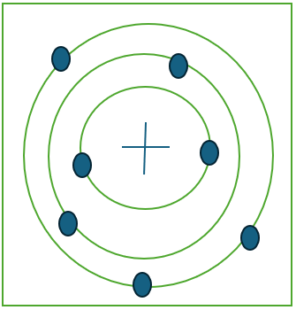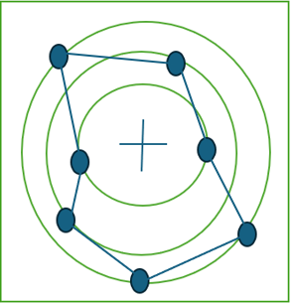
This way we end up with a circular style track, although it is a bit rough, on the next part we will smooth it out using splines (Catmull-Rom).

Generate splines and spline points between these random points to join them together in a smooth fashion.
Splines allow us to join different points smoothly using an interpolation-like behavior.
Interpolation, just to get clear is a mathematics methodology used to estimate unknown values within known values, to create a fit that most likely represents the behavior of those values.
The Catmull-Rom approach creates smooth surfaces, using not only two points, but 4 (P0, P1, P2, P3). This pushes the results to be more natural, since more information is being used, thus the fit is more correct, and correlated to the expected behavior of the track. Therefore, making Catmull-Rom’s approach excellent for our use case.
This is the function we build for Catmull-Rom within the code, which is a direct application of the well known formula for this method.
catmullRom(P0, P1, P2, P3, t) {
const x = 0.5 * ((2 * P1.x) + (-P0.x + P2.x) * t + (2*P0.x - 5*P1.x + 4*P2.x - P3.x) * t*t + (-P0.x + 3*P1.x - 3*P2.x + P3.x) * t*t*t);
const y = 0.5 * ((2 * P1.y) + (-P0.y + P2.y) * t + (2*P0.y - 5*P1.y + 4*P2.y - P3.y) * t*t + (-P0.y + 3*P1.y - 3*P2.y + P3.y) * t*t*t);
return {x, y};
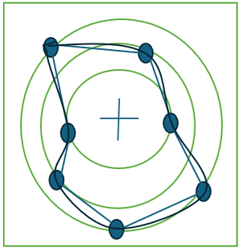
}
Here “t” is a value that ranges between 0 and 1, that indicates how close it is to the next point. On the code we use a 50-step curvature, we get “t” by “t = step/steps”, iterating over: step < steps.
This way we generate a fit that correctly joins the points on the map.

(fun fact, while drawing the diagram, it seems that the word tool for curve, also uses some sort of interpolation fit, possibly Catmull-Rom )

Provide track width by using normal vectors to the spline curve, to extend from the original track design
To extend the design we made previously, we need to add track width. This is a simple process. We calculate the tangent curve on each of the points of the spline curve by analyzing the current point and the next point. Now, we invert that function (slope) to get a perpendicular slope to the spline curve at that point, and we normalize it dividing it by the length of that tangent.
What we managed to do here is obtain a perpendicular vector to the spline curve, granting us the ability to simply extend it by multiplying it with a desired track width (on each side)
This process is then repeated for each step of the spline. This provides a result like this:
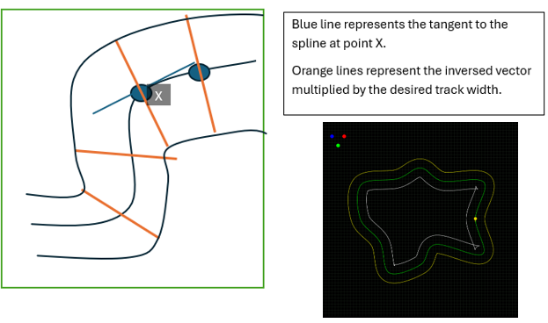

Turn this created track into a grid, where 1’s represent track, and 0’s represent grass. We turn this grid into an array using linear interpolation from the left to the right segments of the track, above the spline.
This process is called rasterization, and to perform this efficiently, we create a grid made from 64x64 (or the desired grid size defined previously) and assign 0 to all elements. Now, we perform a linear interpolation from left to right on all the track edges, which in turn means all the spline points.
Linear interpolation is quite similar to Catmull-Rom interpolation, but it just analyzes 2 points, hence the name linear. This is performed like this:
X = left.X + (right.X – left.X) * t
Y = left.Y + (right.Y – left.Y) * t
The “t” stands again for steps taken from point a to b, we are using an incremental t by = 0.05 each iteration. This provides exact coordinates, probably to exact, so we transform them using the function, Math.floor() from JS, which allows us to round it to the closest integer. After this we just go back to the grid and change grid [y][x] = 1.
We do this for every point in the spline. With this grid in place, we can now use it on the renderer, to display our track

Represent that grid on the renderer
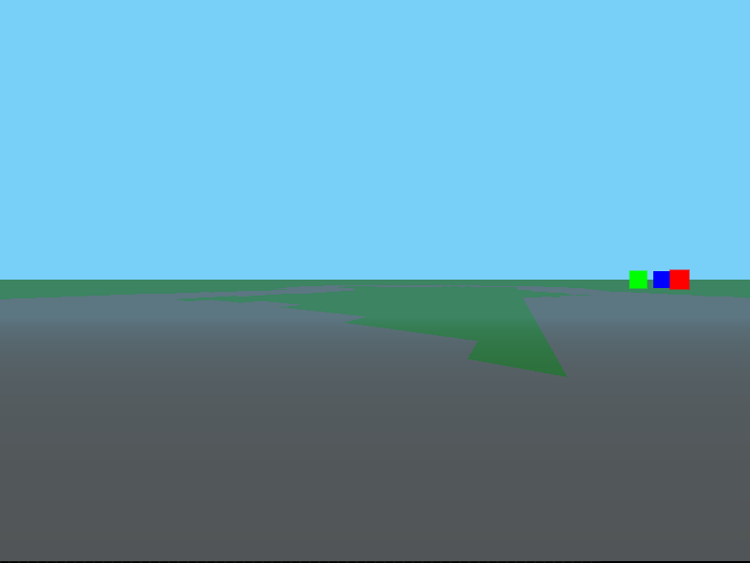
This is the result we got from the testing, we also made sure to properly place the player within track limits, spawning at the first generated point of the track (back from step 1).

Conclusion
This method provides us with closed, randomly generated tracks, which can provide the player with unexpected battles each time they play.
Next in line we will focus on what are the kart physics, and the checkpoint system, which are both essential for the racing gameplay. For now, this is great progress, and proves our game is viable and possible to develop with the resources provided.
Getting outside help from external sites like the ones cited above helped us visualize new ways to approach our problems from a mathematics perspective, and not a literal way like we were first planning to do so.
